**Lesson 23 /26**

**Electromagnetism Activities – Answer key**

**Station 1 Conductors in magnetic fields**

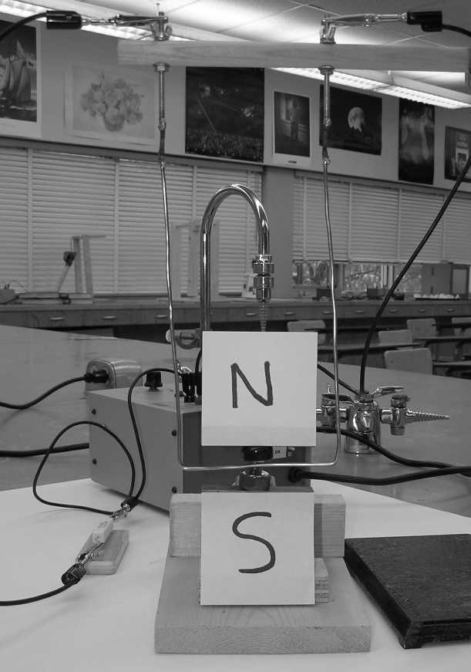In this apparatus, you will find a retort stand with a copper wire hanging between two magnets. A power supply with a current-limiting-resistor is attached to the top of the apparatus. **Turn the power on for brief instances only**.

Procedure:

1 . Before turning the power on – using the appropriate hand rule, predict the direction that the hanging wire will move.

hanging copper wire

2. Turn the power on and note what happens to the wire.

neodymium magnets

3. Reverse the power supply wires at the power supply and repeat #1 and #2.

Questions

* What was the effect of the current running through the wire? Relate what you saw to the open palm hand rule.

checkmark

checkmark

Current through a wire within a magnetic field results in a force that moves the wire to one side. The open palm rule (karate grip) predicted the force direction that was observed.

* Explain what you observed in terms of the motor effect.

checkmark

checkmark

The motor effect is that a current-carrying wire placed in a magnetic field results in a force on the wire. This is what was observed.

## Station 2 Solenoids – induced current

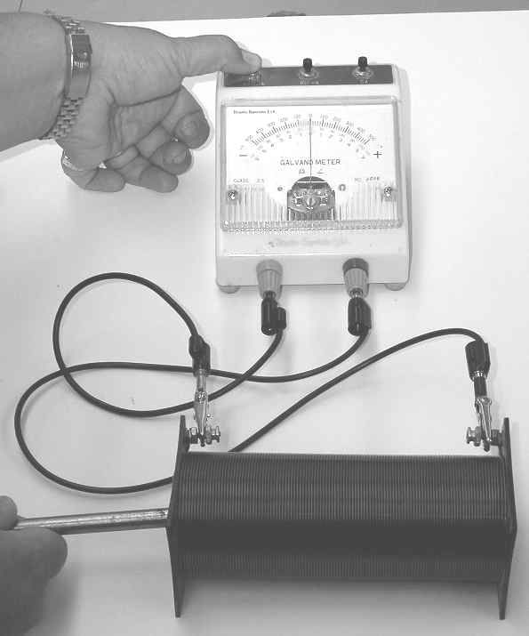

Press down on the far left button of the galvanometer.

In this apparatus, a solenoid is hooked up to a galvanometer. You will also find a neodymium magnet attached to a steel nail on the table. Note: For this station you are not trying to work with the hand rule. Rather you are working with the general principle of induction.

Procedure:

1. Push the magnet into the solenoid core, pause, and then pull it out again. Notice how the galvanometer responds.

2. At the other end of the solenoid, repeat #1.

Questions:

1. What does a *galvanometer* measure or indicate?

checkmark

A galvanometer indicates the presence and direction of electron flow.

1. What was the effect of pushing the magnet into the solenoid and then pulling it out?

checkmark

checkmark

The magnet pushed into the coil induced a current in the coil in one direction and when it was pulled out a current was induced in the opposite direction.

1. In terms of Faraday’s law of induction, explain your observations.

checkmark

Faraday’s law of induction states that a changing/moving magnetic field in a conductor induces a current in the conductor. In this case, we moved a magnetic field through the coil of wire which induced a current in the wire.

## Station 3 Electric generator

At this station you will find a hand-crank generator connected to a small light bulb. **Please do not crank the generator too fast as it will cause the light bulb to burn out**.

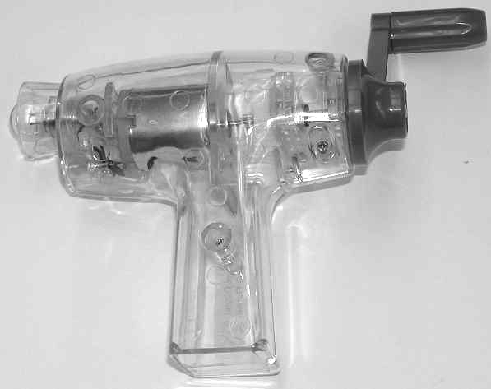

Procedure:

1. Turn the crank of the generator. Notice the result. Note the difficulty in turning the crank.

2. Unscrew the light bulb from the generator. Turn the crank and notice the result. Note the difficulty in turning the crank.

Observations:

Light hooked up:

checkmark

* Cranking (mechanical energy) resulted in light energy.
* Cranking requires effort since one is doing work on the electrons to produce current.

Nothing hooked up

checkmark

* Cranking is easy since there is no circuit and therefore no electric current/energy.

Questions:

1. Starting with the chemical potential energy in your body, what are the energy transformations involved to produce light energy with the generator?

checkmark

checkmark

Body energy (chemical potential) → hand motion (kinetic energy) → cranking the generator (kinetic energy) → electric energy → light energy

* Explain why the resistance on the crank was so different for when the generator did and did not have a light bulb.

checkmark

checkmark

When the light bulb is hooked up to the generator, mechanical energy is being transformed into electrical energy which becomes light energy. Therefore, work is required to make light energy.

## Station 4 Swinging aluminum paddles

In this apparatus, there are two aluminum “paddles” that can swing between the magnetic field produced by two powerful magnets. One aluminum paddle is solid while the other is like a comb with multiple prongs. (Special thanks go to Ryan Gibson for fabricating the paddles.)

Procedure:

1. Using the comb paddle first, lift the paddle to one side of the magnetic field and ten let it swing through the field.

2. Replace the comb paddle with the solid paddle. Draw the paddle to one side and allow it to swing through the magnetic field.

Observations:

checkmark

Solid paddle – the paddle came to a rapid stop as it entered the magnetic field

checkmark

Comb paddle – the paddle swung through the magnetic field and slowed down by a small amount

Questions:

1. Is aluminum metal ferromagnetic ?

No. Aluminum is not ferromagnetic.

checkmark

1. Using Faraday’s law of induction and Lenz’s law, explain how the paddles were affected by the magnetic field?

checkmark

checkmark

The motion of the aluminum paddles through the magnetic field induced circular currents in the paddles. The currents in turn produced a new magnetic field that had the opposite polarity to the original magnetic field. The opposing magnetic fields resulted in a magnetic force that slowed or stopped the paddles.

1. Why was the *comb* paddle not as affected by the magnetic field while the *solid* paddle was greatly effected? (It may be wise to consult with your kind and benevolent teacher to see if your explanation is accurate.)

checkmark

checkmark

The splits in the comb paddle allowed only small currents to be produced in each of the prongs of the paddle which induced only small magnetic fields to oppose the original field. The solid paddle, on the other hand, had a large induced current which induced a large opposing magnetic field. The result was a large magnetic force that stopped the paddle.

**Station 5 The vertical tubes**

In this apparatus, you will find a long hollow copper tube and a long hollow plastic tube. In addition you will find two black objects, one marked with a piece of masking tape.

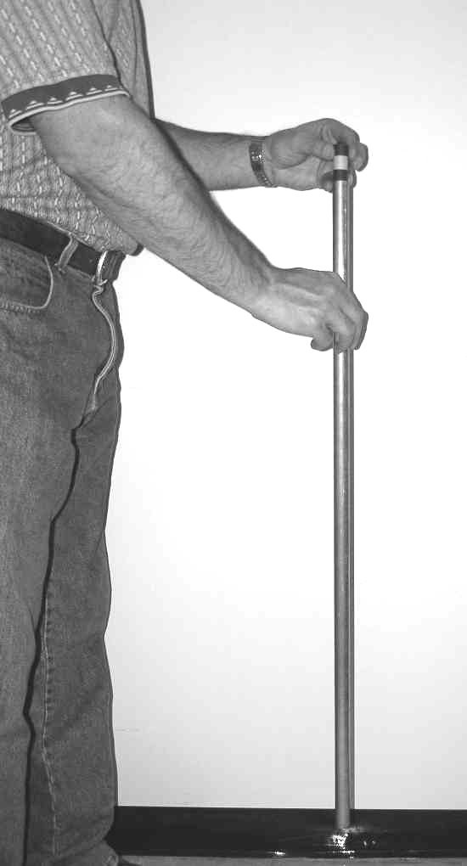

Procedure:

1. Place the black object with the tape in the top of the plastic tube and let it fall through the tube. Note what happens.

2. Place the black object without the tape in the top of the plastic tube and let it fall through the tube. Note what happens.

3. Replace the plastic tube with the copper tube. Repeat steps 1 and 2 for the copper tube.

4. Determine which of the black objects is a magnet and which is not.

Observations:

checkmark

Objects through plastic tube – both objects free fall through the tube

checkmark

Magnet in copper tube – the magnet falls through the copper tube with constant speed

Questions:

1. In terms of Faraday’s law of induction, Lenz’s law and the resulting forces, explain what you observed.

checkmark

checkmark

checkmark

Fm

Fg

For a magnet falling through a conductor the motion of the magnet induces a circular current in the tube (Faraday’s Law). The induced current induces a new magnetic field that opposes the falling magnet (Lenz’s Law). Since the speed of fall is constant we know that a = 0 and therefore Fnet = 0. In other words, the magnetic force balances the gravitational force.